  - Overview changes software CheckerIII .

  - Ver.1.60 [27.Oct.2017]

ADD MODELS VRV ( D3-NET connection only )
VRV-4W-3 (for DENV) | RWEYQ8-14T9Y1B
Ref_ZEAS-C | LSVLP8-15(C,CD),LSVMP8-15(C,CD),  LSVFP8-10C,LSVFP15-20CD

  - Ver.1.59 [09.Feb.2017]

ADD MODELS VRV ( D3-NET connection only )
INV chiller | UWAXP125-750A,UWAXP125-750AZ (japan model name)
R407C chiller | UWYP125-750A,UWAP125-750A,UWYP125-750AZ,  UWAP125-750AZ (japan model name)

  - Ver.1.58 [10.Jan.2017]

ADD MODELS VRV ( D3-NET connection only )
VRV5 (for China) | RUXYQ8-66BA
multi-function VRV for China | NRZQB224-450Y1, NRZQB112-160V2C, NHBB160V2C, NHBBN160V2C, NHBB160H3V2C
VRV4i (8HP) for DENV | RKXYQ8, RDXYQ8T7
VRV4S for North America | RXTQ36-60TAVJU

  - Ver.1.57B [22.Mar.2016]

ADD MODELS VRV ( D3-NET connection only )
 | Hong Kong Home VRV-S | RJZQ4-6AAV, RJZQ7-12AAY
Modification
VRV4W | Fixed a bug that does not recognize some of the models
Centralized operation Error code | Wrong error code correction  secound character H,J (correct): B,D (wrong)  ex. AH -> AB, UH -> UB
Fixed some bugs in the software

  - Ver.1.56B [18.JAN.2016]

ADD MODELS VRV ( D3-NET connection only )
 | VRV4W (water cooled heat-pump& heat-recovery)T7 . Data for RWEYQ-T from patch 1-55b onwards was by mistake removed originally created in 1.54A. | RWEYQ-T7  RWEYQ-T7Y1BS  RWEYQ-T8

  - Ver.1.56 [21.Oct.2015]

ADD MODELS VRV ( D3-NET connection only )
 | VRV4i (heat-pump for indoor installation) | Compressor module : RKXYQ5T7Y1B,  Heat-exchange module :RDXYQ5T7V1B

  - Ver.1.55C [16.Sep.2015]

ADD MODELS VRV ( D3-NET connection only )
 | VRV-4S (for DENV) | RXYSCQ4,5TMV1B “compact 1ph”  RXYSQ4,5,6T7V1B “standard 1ph »  RXYSQ4,5,6T7Y1B « standard 3ph »  RXYSQ8,10,12TMY1B « large 3 ph »

  - Ver.1.55B [28.Aug.2015]

ADD MODELS VRV ( D3-NET connection only )
 | VRV-4Watercooled-2nd generation (for DENV) | RWEYQ8,10T8  (if HR compatible to :  - Or BSVQ-P  - Or BS-Q-A)

  - Ver.1.55A [ 15.Oct.2014 ]
  - Modifications :
  - VRV-4R :
1/ Temperature modifies the value at below 0 degrees :
      - comp._suction_pipe_temp.
- receiver_gas_purge_temp.
- heat_exchanger_liquid_pipe_temp.
  - 2/ FAN step : modify graph scale max value 10 to 100

  - Ver.1.55 [25.Jul.2014]

ADD MODELS VRV ( D3-NET connection only )
 | VRV-4R REYQ8-54T7Y1B [ REYQ8-20T, REMQ5T ] | REYQ8-20T, REMQ5T

  - Ver.1.54B [10.Jan.2014]

ADD MODELS VRV ( D3-NET connection only )
 | - VRV4 for North-America | - RXYQ72T
 | - VRV4 for ASEAN | - RWEYQ-PY17

  - Ver.1.54A [ 11.Nov.2013 ]

ADD MODELS VRV ( D3-NET connection only )
 | - VRV4W for DENV RWEYQ8-10T7Y1B | - RWEYQ8-10T7Y1B

  - Ver.1.54 [ Jul.2013 ]

ADD MODELS
VRV4(Q) for DENV | RXYQQ8-20T7Y1B
VRV-X (for China) | RUXYQ8AB
Home VRV (for China) | RJQ10ABY

Modification
- indoor unit : add BRC sensor temp. (remote controller thermo.) for latest VRV indoor units.
  - Ver.1.53C [ Jan.2013 ]

Modification
- Altherma LT : modify the contents of several items that were wrong. ( Same content as the MEGA altherma )
- VRV3 for US : Fixed a bug that Inverter_temp. Becomes abnormal when the value below 0 degrees Celsius.
  - Ver.1.53B [ Dec.2012 ]

ADD MODELS
VRV ( D3-NET connection only )
Altherma LT | HXY80-125A

  - Ver.1.53A [ Nov.2012 ]

Modification
- WSHP Indoor unit support WSHP Indoor unit.

  - Ver.1.53 [ Sep.2012 ]

ADD MODELS
VRV ( D3-NET connection only )
VRV4 HP | RYYQ8-54T7Y1B, RXYQ8-54T7Y1B
indoor unit for computer room | DFVP400-500M (for Thailand)

Modification
- Small Inverter Chiller : change item name ( outdoor unit part )

  - Ver.1.52 [ Jun.2012 ]

ADD MODELS
VRV ( D3-NET connection only )
McQuay WSHP | S2UWSQ36A (WSHP 3ton 4HP)  S2UWSQ48A (WSHP 4ton 5HP)

  - Ver.1.51C [ May.2012 ]

ADD MODELS
VRV ( D3-NET connection only )
Total Solution VRV ( Mega Altherma ) | HXHD125A7V1B

  - Ver.1.51B [ Apr.2012 ]

ADD MODELS
VRV ( D3-NET connection only )
Small Inverter Chiller ( Mega Altherma ) | EWAQ016-064BAW

Modification

VRV3 for China : The wrong place was corrected.
- Outdoor unit current
- Subcooling_heat_exchanger_gas_temp., Subcooling_heat_exchanger_liquid_temp.

  - Ver.1.51A [ Mar.2012 ]

ADD MODELS
VRV ( D3-NET connection only ) VRV3W (Water) other type VRV3W(Water) : RWEYQ8-30P7 - The 2nd version model of the VRV3W addition

Modification
- VRV3 for China : Inverter fin tmp. Fault in case inverter fin temperature is minus is corrected.

  - Ver.1.51 [ Feb.2012 ]

ADD MODELS
VRV ( D3-NET connection only )
VRV3 for China | RHXYQ8-48SY1, RHXYQ10-42SAY1

Modification
Supposing it enlarges a screen using a high resolution monitor, an error will occur.
When tendency to use a high resolution monitor (FullHD 1920x1080 grade) of 1800 pixels or more and tended to display an operation display screen etc. greatly, the fault which carries out an abnormal end was corrected.

  - Ver.1.50C [ Dec.2011 ]

ADD MODELS
VRV ( D3-NET connection only )
VRV for DENV | RXYRQ8-18P7W1B

  - Ver.1.50A [ Mar.2011 ]

Modification

Altherma Indoor Unit revised

1) Data name modified
Data name : Symbol ==> Parameter name ex. TwR ==> Return water temperature, HTh1 ==> Remocon ambient temperature

2) Display unit for pump revolution speed
Changed from rps(revolution per second) to rpm(revolution per minute)

3) 4 parameter items added
Add item : SWF(flow swith) , ST2L(external room thermostat cooling) , SV32(space heating/cooling 2way valve) , SVE(cooling solenoid)

4) Conversion table for Tsch(R134a liquid temperature), HTdi(Discharge temperature) temp. has been corrected
Doubled (x2) from original value

5) Scale for EV and Pump revolution value modified
Pump revolutions : 4000 , EV_L : 2000 , EV_H : 1000 , EV_C : 2000

  - Ver.1.50 [ 15.Dec.2010 ]

Modification

1. add Detail data list at Opration Data display
add new menu Opration Data Display[Detail]. The screen where the item (period) displayed in the graph was displayed by the list was added. As a result, it comes to be able to confirm the change of the value not understood easily in the graph directly by the numerical value.
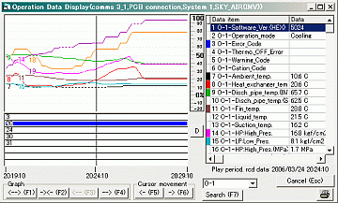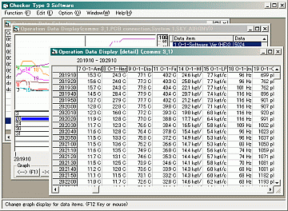
The data that can be displayed is the same as the graph (the analogue 8 points, digital 8 points, and 16 points in total). The period is a period displayed in the graph. (After changing the graph, changing the item and the period displays it again. )

2. Screen size adjustment for Windows-7, Vista, Xp
It was partly modified to turn Windows 7, Vista, Xp.
The matter that a part hid and which wasn't indicated was modified by "Display Operation data" that the size of window can be changed, the indication of the "Customer data Selection" screen by the default of Windows 7, Vista, Xp.
Phenomenon :
A standard window frame is wider than the former mode (the classical mode) with Windows 7, Vista. Therefore, an indication area became small, and a part couldn't be indicated any more. And, a part under window partly broke off because top title part was wide even with Windows Xp.
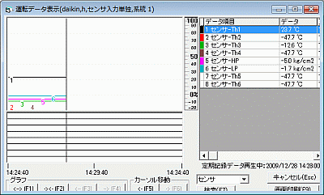Windows Vista
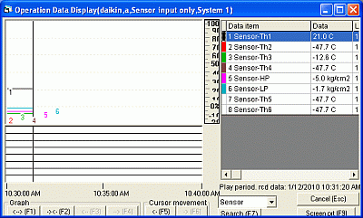Windows Xp
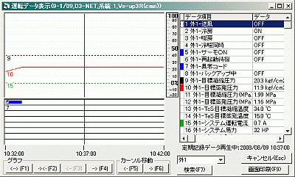Windows 2000
It wasn't understood because development and a test environment were confirmation in the classical mode of Windows2000 and Windows95. Indication was checked with Windows2000.
It was found out this time in the movement confirmation of Windows 7.
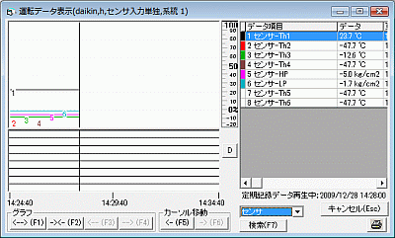Correspondence :
It was changed to compute arrangement in consideration of the frame of window.
After it copes with it. Windows Vista
Windows Xp

3. Change Installer
change software instller.
Visual Basic V5.0 Installer -> Visual Studio Installer (Visual studio 6.0 base)

4. The screen print button of the driving data display is changed.
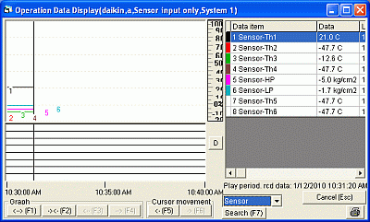
The screen print button is changed (Change from the character to the icon).
The confirmation of "Print Screen Image. OK?" is added the print soon with the screen print button once. It was prevented from being printed when pushing by mistake.

ADD MODELS
VRV ( D3-NET connection only )
VRV for North America | in-unit | FXTQ
 | out-unit | RZQ18/24PVJU
Altherma | Altherma HT | -
 | Mega Altherma | EMRQ8-16AAY1,  EKHVMRD50-80AAV1, EKHVMYD50-80AAV1
ZEAS for Low Temp. | New Firm Ver. | LRLEQ5-20A(Y1), LRMEQ5-8A(Y1)

